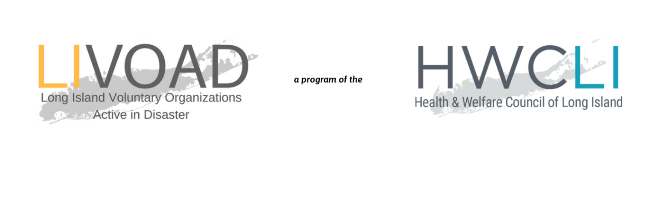

COVID-19 LIVOAD RESPONSE

LIVOAD STANDING CALLS

Tuesdays & Fridays  11:00AM | To join from your computer, tablet or smartphone:  https://www.gotomeet.me/HWCLI/covid-19  You can also dial in using your phone.  +1 (408) 650-3123  Access Code: 929-959-189
LEGAL CONCERNS SUBCOMMITTEE CALLS

Wednesdays  3:00 PM | To join from your computer, tablet or smartphone:  https://www.gotomeet.me/HWCLI  You can also dial in using your phone.  +1 (646) 749-3122  Access Code: 973-021-205

LIVOAD – Legal Subcommittee Call
Wednesday March 25, 2020
3:00PM
Call Notes
On the Call: Tom Maligno, Chair (Touro Law Center), Rebecca Sanin (HWCLI), Marissa Hiruma (HWCLI), Jennifer Gunderlach (Hofstra Law), Jeffrey Seigel (Nassau Suffolk Law Services), Kerry Tenure (Legal Aid Society), Linda Weissman (Touro Law Center), Anne Dibble (Community Legal Advocates of NY), Elise de Castillo (Carecen), Gale Berg (Nassau County Bar Association), Liz Justesen (Legal Aid Society of Suffolk), Kathleen Cammarata (Legal Aid Society of Suffolk), AveMaria Thompson, Esq. (Senior Citizens Law Project), Denise Doty (Senior Citizens Law Project)

LIVOAD/Legal Subcommittee Overview
- The Long Island Voluntary Organizations Active in Disaster (LIVOAD) is designed to respond during the ongoing crisis and form a subsequent Long-Term Recovery Group (LTRG) to address continuing need in the aftermath of regional disasters.
- The LIVOAD is currently activated to respond to the public health crisis.
- The goal is to use the legal response to Superstorm Sandy as a template. From there figure out how we will respond, resources we have, the resources we are creating.
- During Sandy, a hotline was created and manned by pro bono volunteers.
Today’s call will discuss:
- Overview of capacity from different legal groups.
- Addressing specific emerging needs.
- Creation of one centrally housed legal resource guide.
- Volunteer management.
Capacity/Agency Updates:
- Nassau Suffolk Law Services
- Full remote access
- Their advice and call center is open.
- Updating information on their website related specifically to OCA and the city/local courts.
- When clients call, they will reach a voicemail and someone will call back in 24 hours.
- Community Legal Project
- Libraries are shutdown but the phone number is still taking calls.
- People who are outside the normal federal poverty level can be referred.
- Not currently setting up in person consultations
- Pro bono attorneys working on setting up consultations over the phone.
- Legal Aid Society
- Small crew covering applications
- LIFT (Legal Information for Families Today) is currently operating (information will be posted to HWCLI COVID-19 resource page)
- Ready to assist people who don’t normally qualify for legal services.
- Hofstra Law
- Collection of students ready to dedicate for discrete pro bono projects.
- Pro se legal assistance, or even long-term assistance. Normally operating out of the Central Islip Court, but now operating virtually over the phone and with Zoom conferences.
- Unemployment Action Center is fully functional.
- Pro se resources located on their website.
- Legal Aid Society
- Have staff working on an extensive list of resources in a Google Doc to share.
- Senior Citizen Law Program
- Seeing a decrease in calls.
- Getting back to clients within one day.
- Fully operational for landlord/tenant issues, Medicaid or anything related to DSS.
- CARECEN
- Staff are 100% remote.
- Assisting with primary needs, immigration legal services, health-related issues, rent and unemployment matters.
- Also compiling resources to share with clients.

Emerging Concerns:
- Increase in calls from two parent health care professionals interested in updating their will when it comes to guardianship.
- Small business loans & what to do about them: During Sandy, many were encouraged to apply for SBA loans, which led to duplication of benefits later on.
- How do we handle the significant increase in unemployment cases?
- Housing
- Courts are currently closed so no one will be immediately evicted - but they can’t also be searching for new housing at this time.
- Mass eviction prevention when this lockdown ends.
- Employer concerns - what happens when a staff member tests positive?
Volunteers:
- Volunteers ready and willing to provide law services:
- Private attorneys and law firms want to volunteer
- Law students in need of hours.
- National Law Student Associations
- ADA
Next Steps:
- Take another week to think about the best way to go about legal resource hotline.
- Continue gathering information/resources that we can house in a central place.
- Formalizing projects for the law students to work on.

