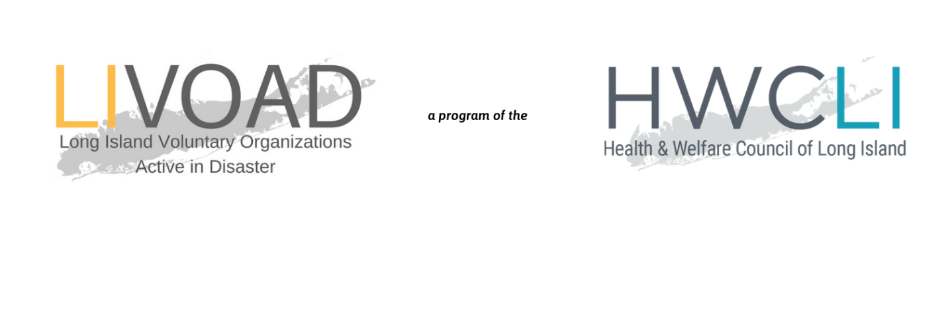

COVID-19 LIVOAD RESPONSE

Family Violence Subcommittee Call
Thursday, March 26, 2020
4:00PM
Call Notes

LIVOAD STANDING CALLS

Tuesdays & Fridays  11:00AM | To join from your computer, tablet or smartphone:  https://www.gotomeet.me/HWCLI/covid-19  You can also dial in using your phone.  +1 (408) 650-3123  Access Code: 929-959-189
FAMILY VIOLENCE SUBCOMMITTEE CALLS

Thursdays  4:00PM | To join from your computer, tablet or smartphone:  https://www.gotomeet.me/HWCLI  You can also dial in using your phone.  +1 (646) 749-3122  Access Code: 973-021-205

Attendees
Cindy Scott, The Safe Center
Colleen Merlo, Long Island Against Domestic Violence
Dolores Kordon, Brighter Tomorrows
Loretta Davis, The Retreat
Mary Hallowell, HWCLI
Rebecca Sanin, HWCLI
Reina Schiffrin, VIBS
Tommi-Grace Melito, HWCLI
Identifying Challenges
- Staffing Concerns
  - Management over past weeks has included attention to staff mental health.
  - Some shelters are reaching out through school districts to appeal to staff who are working from home, who might be able to pick up a shift at a shelter to abate oncoming staffing crisis. School employees have already been cleared to work with children.
- Client Management and Messaging around Social Distancing
  - Some have experienced pushback from clients in regards to social distancing and “stay at home” equivalents for shelters. Clients are not able to leave and return to the shelter as frequently as during normal conditions, and can only go to essential appointments.
- Facility Cleaning
  - HWCLI to distribute guidelines for cleaning commercial spaces.
- Hotline Challenges
  - With abusers much more likely to be within earshot, those who would be calling into the hotline are not as able to do so.
  - The VIBS chatroom has been much busier, which might also be due to the appeal of texting/chatting to younger clients.
  - There is a need for messaging: you can ask a friend or family member to reach out to the hotline on your behalf.
  - Additional need for messaging to those who have not been in DV situations before and might not be familiar with resources.
- Lack of Contact/Oversight
  - With schools closed, there is also a crisis created by the lack of oversight or connection with mandated reporters in schools.

Housing Crisis for COVID-19 Positive Shelter Residents
- Nassau County has identified motel locations for persons experiencing homelessness and victims of domestic violence who are either positive or suspected positive for COVID-19. These rooms are self-contained for isolation.
  - Rooms can be occupied by people who either call into the hotline with symptoms or who are living in the shelter and develop symptoms.
  - Additionally, there is a small unit for high-safety-risk clients.
  - LIFQHC will provide medical check-ins for all residents.
  - Food will be provided by the shelter.
  - TSC is potentially able to provide toiletries to DV shelter residents.
  - Security at present moment will be the staff of the hotels/shelters – would be ideal if they were trained in DV but conversations can continue.
- Suffolk County information is still to follow regarding how DV shelters can access hotel space for their clients, and also on whether medical checks will be provided for these residents.
- Many residents of each county seek shelter in the opposite county for heightened distance from the home.
- The DV shelter system will soon be overloaded, and housing needs to be addressed.
Reimbursements & Financial Concerns
- Status and security of reimbursements from the County remains something of a gray area from funders.
- To secure future reimbursements, all organizations should have written work from home policies and agreements with each of their individual employees, in addition to confidentiality agreements.
  - The Safe Center will distribute a sample agreement.
- Send all specific questions about reimbursements to Tommi-Grace Melito, tgmelito@hwcli.com so that HWCLI can bring concerns to the county.
- While assurances have been issued by the County, will be working to secure written agreements.
- SBA Loans could provide a viable option, but remain cautious as during Sandy these loans proved to be harmful to many recipients.
- Fiscal staff of nonprofits are truly essential.
- Remaining questions:
  - Is it possible to ease requirements for vouchering and backups?
  - Is it possible to have written assurances of reimbursements?
  - Is it possible to ease paper copy mandates from the County?

Action Items
- Send Rebecca Sanin, rsanin@hwcli.com, how many PPE masks your location requires. Delivery should be possible within the next five days.
- Send recommendations from the Nassau model of shelter housing to Rebecca Sanin, rsanin@hwcli.com to enable HWCLI to work with Suffolk County on developments.
- Send all specific questions about reimbursements to Tommi-Grace Melito, tgmelito@hwcli.com so that HWCLI can bring concerns to the county.
- The Safe Center will distribute a sample Work From Home agreement.
- HWCLI will distribute guidelines for cleaning commercial spaces.

Next Steps
- Develop messaging and strategy for connecting Long Islanders with resources and housing safely.

